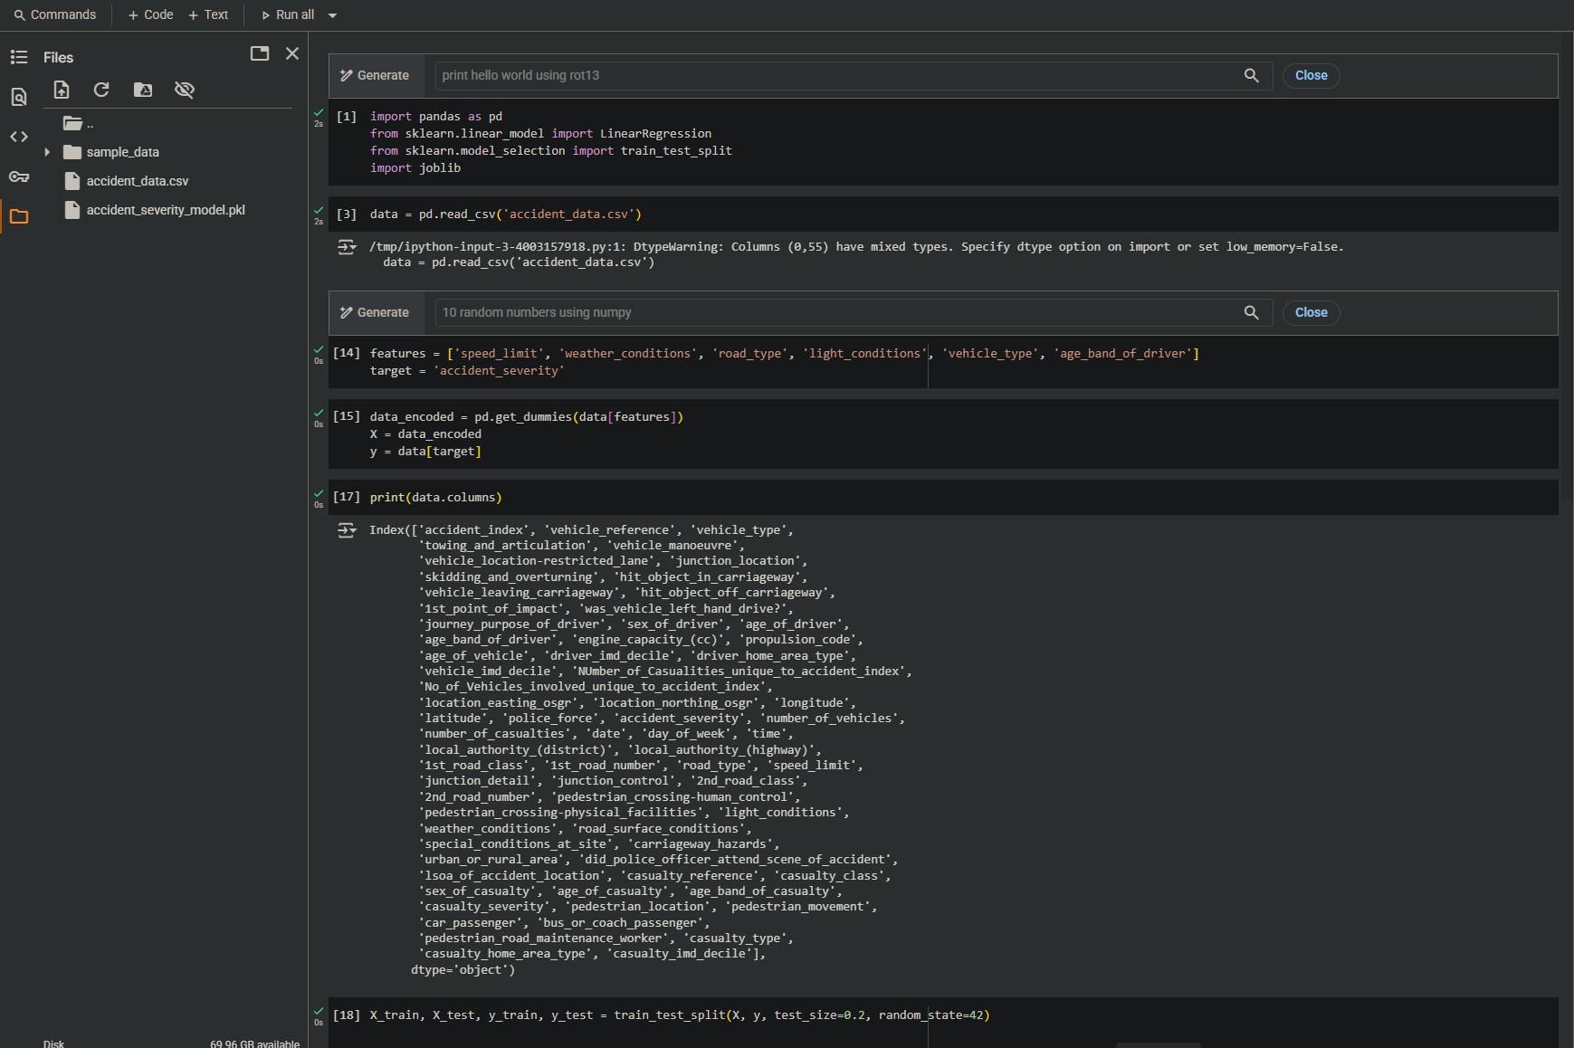

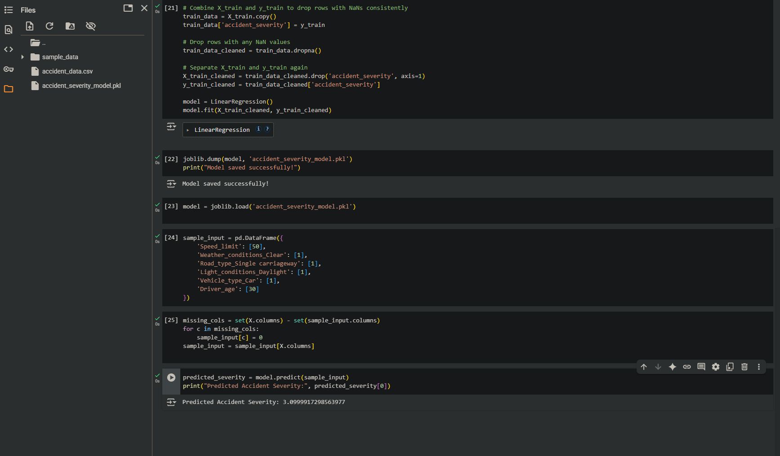

This model could assist policymakers in underdeveloped countries by:

* Identifying high-risk scenarios (e.g., poor lighting, younger drivers).
* Prioritizing road safety interventions (e.g., lighting in rural areas).
* Creating driver education campaigns targeting vulnerable groups.
* Reducing emergency response time through severity prediction.

GITHUB LINK

<https://github.com/Gichobi321/road-accident-severity-model>